Depth-map produced case study used in Based on multi-camera autostereoscopic multiview 3D immersive advertising content *

Hyoin kim

Graduate School of Design PhD
Dongseo University, 47 Jurye-ro, Sasang-gu
Busan 47011,South Korea
jaivim@hanmail.net

Abstract

This study is a study of the production plan of "glasses-free 3D Realistic advertising content, which is emerging as a new paradigm in the advertisement market. Autostereoscopic three-dimensional display is an IT technology capable of stereoscopic viewing without glasses. Use the Original image and Depth-map gives a three-dimensional in the Image. Among the Parallax barrier method Lenticular lens system, in this study, taking into account the viewing angle, visual fatigue was selected Lenticular lens system. Original Image has taken the subject using the Blue-screen and Depth-map was produced in each level A and level B. A level is a gray scale deviation in Step 3 below, level B is to prepare a Gray scale deviations above step 3.The level of protection for the demonstration, users can choose. Depth-map for the type of advertising is far highlighted the sense of space level A. Depth-map of the type suitable close range advertising was subject to a sense of volume in the highlighted level B.. keywords: three-dimensional, Autostereoscopic and depth-map

I. Introduction

Advertising has evolved into radio and TV, the Internet started to inform by writing a letter to the paper through the neon signs in accordance with the advancement of technology and the flow of the times [1]. In modern times, and the different forms of advertising that combines the visual elements and IT technologies emerge. interactive AD, media-facade AD, hologram AD, etc. This is a prime example. By break away from traditional advertising methods to induce consumers new experiences and interests, and the seller have to improve the effectiveness of marketing. In this study, we selected the ad production plan taking into account the consumption of the IT environment, technology and advertising effects on contemporary issues that reflect the immediate consumption patterns to take advantage of in-store technology Autostereoscopy research 'Autostereoscopy 3D' technology is viewed as a new paradigm in the advertising market in that it provides realistic caused to consumers and the fun and excitement by viewing stereoscopic images without wearing stereoscopic glasses [2]. Global food company 'Chiquita' the six months proceeding the autostereoscopic 3D display for utilizing advertising in 2012[3].
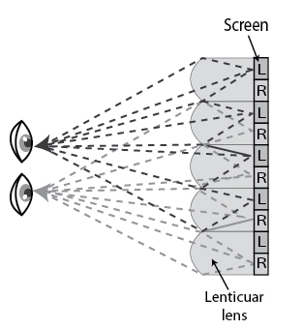
Fig. 2 Lenticular lens. [6]

II. Propose approach
2.1 Autostereoscopy display
Autostereoscopy is any method of displaying stereoscopic images without the use of special headgear or glasses on the part of the viewer. Because headgear is not required, it is also called 'glasses-free 3D' or 'glassesless 3D'[4]. There are two broad approaches currently used to accommodate motion parallax and wider viewing angles: eye-tracking, and multiple views so that the display does not need to sense where the viewers' eyes are located.
2.1.1 Parallax barrier
The parallax barrier divides the light so that different patterns reach the viewer's left and right eyes, creating the perception of a three-dimensional image. But It has the disadvantage that the narrow viewing angle, the brightness of the image decreases.
2.1.2 Lenticular lens
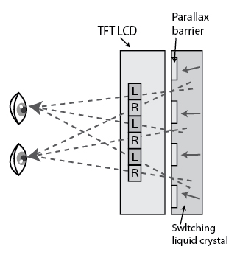
Fig. 1Parallax barrier. [5].
A lenticular lens is an array of magnifying lenses, designed so that when viewed from slightly different angles, different images are magnified. where the technology is used to give an illusion of depth, or to make images that appear to change or move as the image is viewed from different angles.
The wide viewing angle compared with the Parallax barrier brighter picture brightness. When a mismatch is the distance between the display and the lens brings the visual fatigue and Cross talk and Moire phenomenon occurs when viewing stereoscopic images.
In this study, considering the convenience of the consumer and the viewing angle and visual fatigue for the representation of the content and to the stability of the Autostereoscopy, lenticular lens method was chosen.

2-2. Shooting commercials
In order to have a stable three-dimensional stereoscopic spatial it shall be clearly identified as the main subject and Background. Because it 'Autostereoscopy content' content is also based on the stereoscopic image to separate the main subject and Background. In both eyes (left / right) and with more than eight cameras, not two cameras mimic glasses-free stereoscopic content is the separation of main subject and Background significantly affect the quality of content. Therefore, the main subject being the main on advertising in this study were taken using a Blue / Green screen.
Background image was conducted for content creation in a manner that produced separately by using computer graphics and composit the main subjects in the Blue-screen.
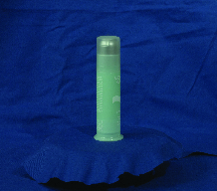
Fig. 3 Blue screen shooting.

2-3. Depth-map
'Autostereoscopy content 'is needed for Original image (2D) and built in Grayscale depth-map. Depth-map provides depth information and is used to adjust the volume and depth of the space object and the background. The study was divided into "close-AD" and "far-AD" the ad, depending on the distance to the consumer and in-store advertising methods see your ad in the store.
2.3.1 Depth-map type
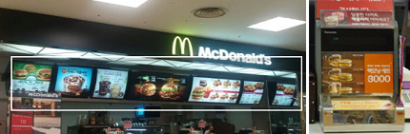

Fig. 4. Far-AD (left) / Close-AD (right).
Depth-map type selected is different depending on whether the reproduction speed of the content, the scene change rate, content interaction whether or not. Produced in this study, autostereoscopic 3D advertising content is as follows.
Playback speed is the same as the Web to 24f / s. However, conversion of the scene is relatively slow as compared with the film image interaction has not been applied.
TABLE I
Autostereoscopy 3D contents

AD | Paly  speed | Conversion  rate | interaction | distance
cosmetic | 24f/s | slow | N | Close
Menu A | 24f/s | slow | N | Close/Far
Menu B | 24f/s | slow | N | Close/Far
Menu C | 24f/s | middle | N | Close/Far
Menu D | 24f/s | middle | N | Close/Far

In the results obtained in previous studies, autostereoscopic 3D Ad Types of Depth-map with the conformity to content creation is the color difference between the gray scale is configured as a 'Type B' with at least three levels of the color difference consists of three phases' Type C 'to be.[7]
TABLE II
Depth-map Type B & Type C in previous studies

Original image
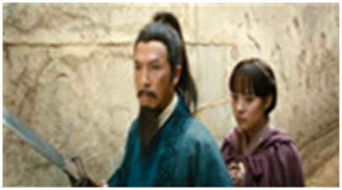
Type | Depth map
Type  B | 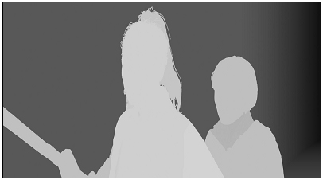
Type  C | 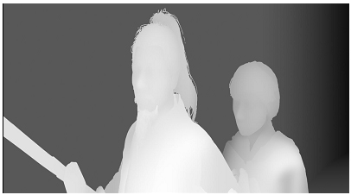

III. Making Depth-map

The best results will be obtained if your computer word-processor has several font sizes. Do not use fonts smaller than the fonts specified in Table I. As an aid to gauging font size, 1 point is about 0.35 mm. Use a proportional, serif font such as Times or Dutch Roman.
3.1 Process
For the production 'glasses-free 3D advertising content' Subject image that is used in the Blue screen shooting, and Background is made using computer graphics. so, two images are a composite manufactured by the Original image. Production process is as follows.
3.2 Separate - Subject
TABLE III
Production process
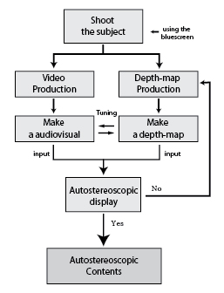

To produce an effective Depth-map, Separate to the Original Image in audiovisual production, separated by top & bottom, front & back, camera angle subject.
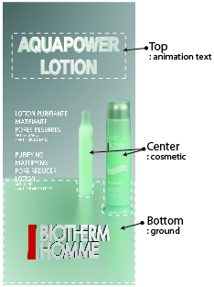 | 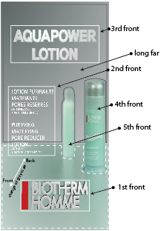 | 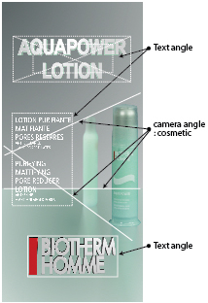
Top/bottom | Front/back | Camera angle
Fig. 5 Separate : Subject & Text.
3.3 Extraction : gray scale color
The ad used in this study is the moving image and the Subject text. In other words, Depth-map should be changed and also the levels of gray sacle color depending on the movement of the subject and text. In the production of the Depth-map level A and level B, this study is the 3D program was used as a method for extracting a gray scale color in proportion to the subject of the motion (speed, direction). Color extraction using a 3D program is the volume can be expressed in the subject and has the advantage of reducing the amount of time depth-map creation.
151 frame
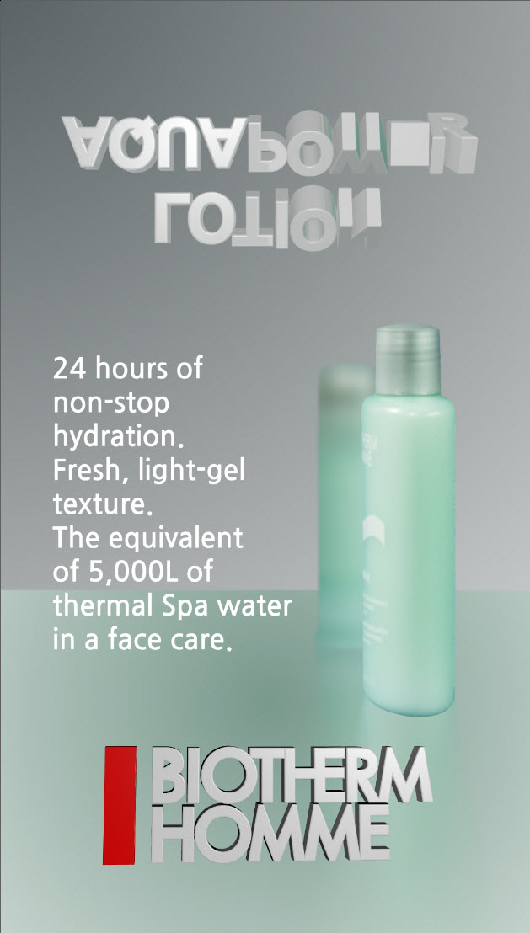 | 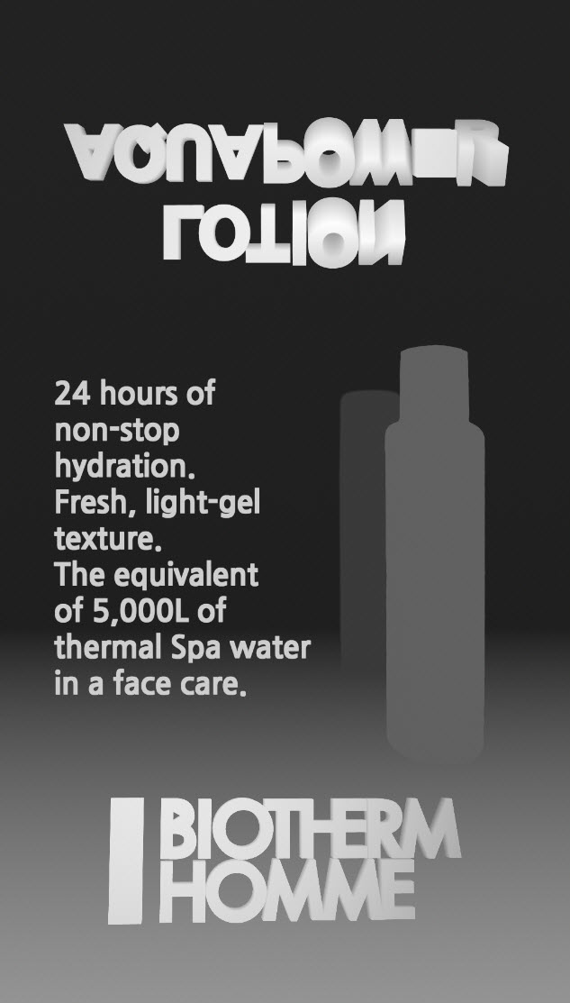 | 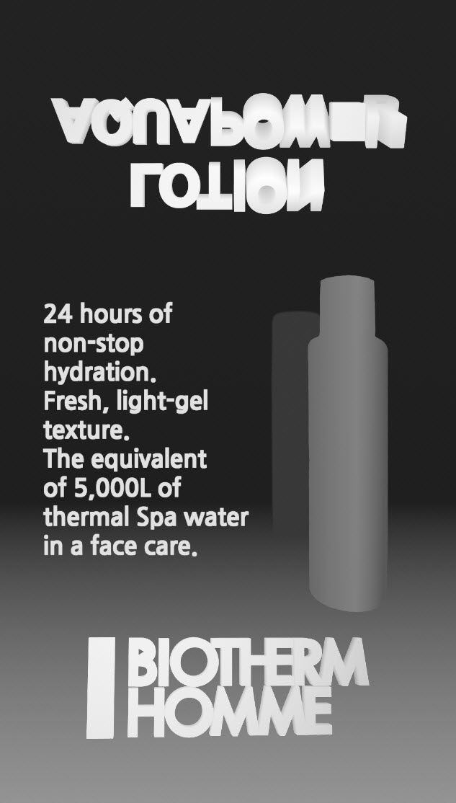
Original | Level A | Level B

Fig. 6 Depth-map level A, level B (According to the frame)
400 frame
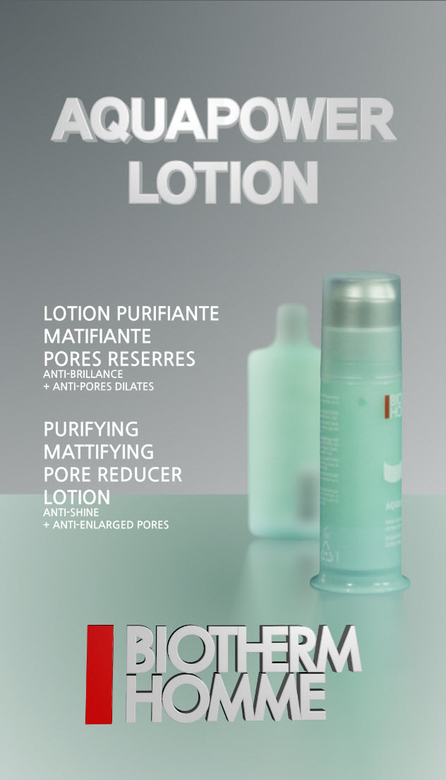 | 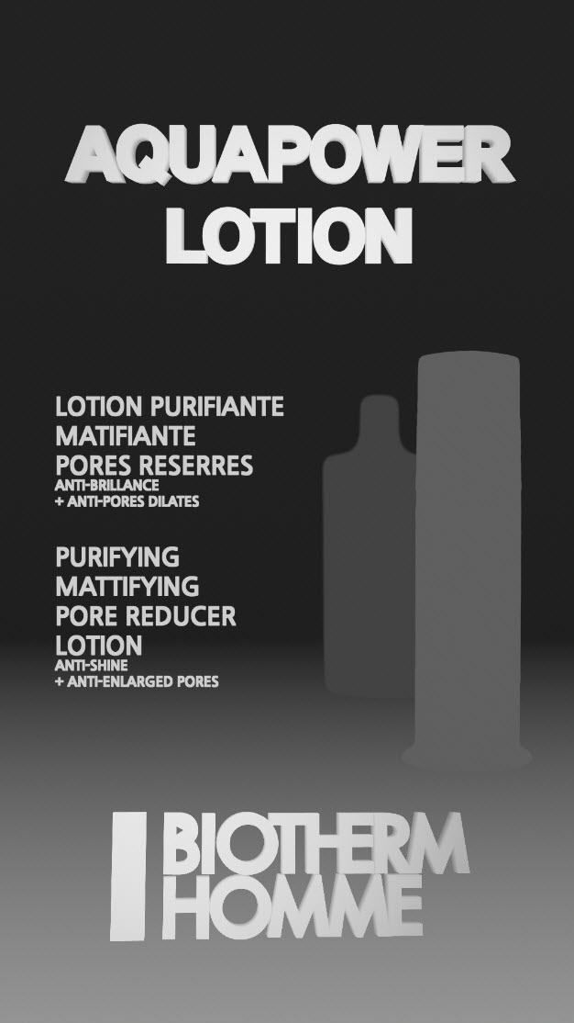 | 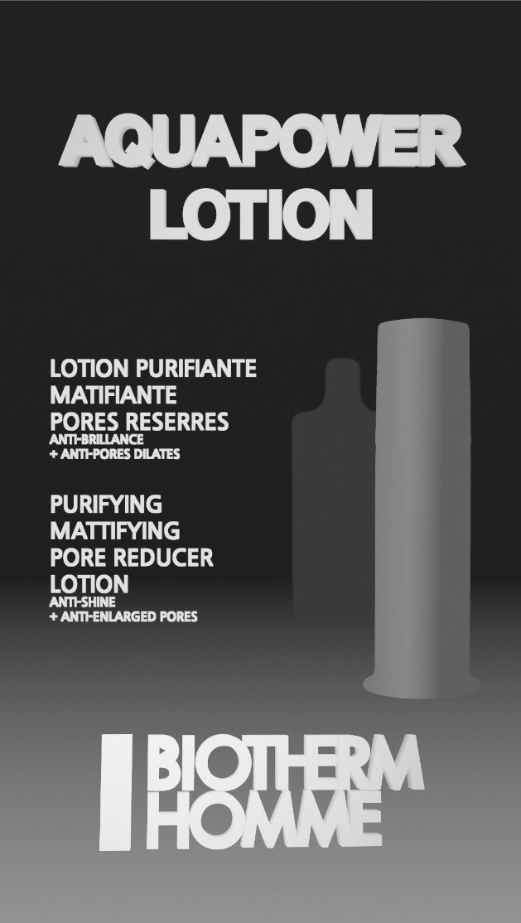
Original | Level A | Level B
Value 'Zero Parallax' is the value you want by typing in Autostereoscopy display it is possible to power control of the extrusion. In addition, it is also easy to set up and modify the intensity of the color adjustment projected in the Depth-map.
600 frame
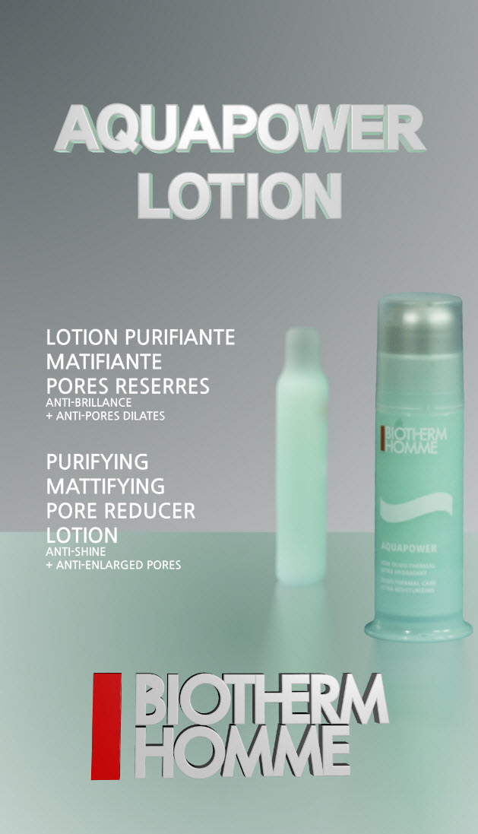 | 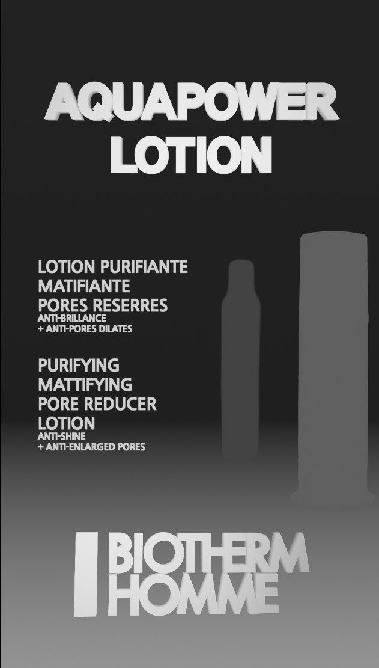 | 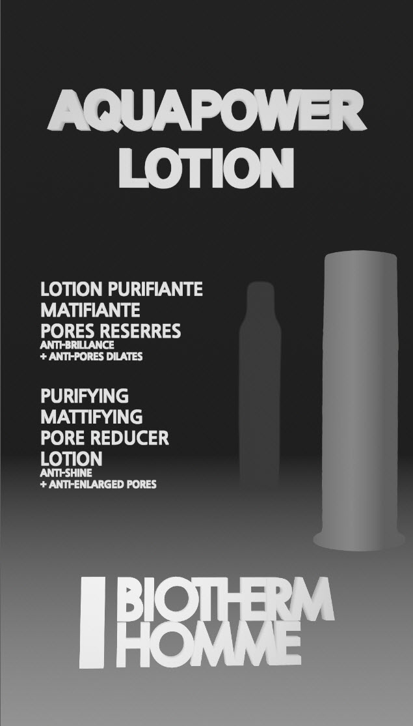
Original | Level A | Level B

IV. Application and manifestation

An autostereoscopic content obtained in this study, 'Korea VR expert forum and the conference (in R.O.K, 2016) "was held in a public demonstration of the target audience.
After demonstrating target audiences, through a simple interview to give a positive response and negative response to the 'Autostereoscopic AD content'.
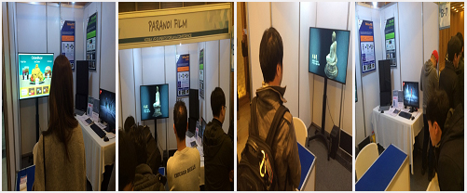
Fig.7 korea VR Experts forum & conference(2016).

V. Conclusion
TABLE IV
Response to Autostereoscopic 3D contents

Positive | Negative
Subject of the  volume improved | three-dimensional particle effect is not sufficient. (smoke, fireworks )
Subject and background are separated improved Fill-space
three-dimensional protruding area setting and modifying convenient. | Generated according to the difference between the readability text.
Visual stability of the consumer

This study is a proposal for a 'Autostereoscopy realize ad content' production plans. Among autostereoscopic 3D Display, in consideration of the viewing angle it was selected visual fatigue Lenticular lens system. also, Considering the accessibility and convenience for the creation of a beginner, Autostereoscopy proposed a production method that uses Depth-map that provides the Original image and depth information.
In-store advertising based on the distance between the advertising and the consumer, were divided into two kinds of close-AD and Far-AD. Depth-map was created with level A and level B according to the two types of ads. Subject volume level B of the emphasis on realism is suitable because of the suitability of the consumer experience in public demonstrations to the case of Close-AD, the distance between the consumer and the proximity advertising.
In the case of Far-AD, apart from the distance between the consumer and the advertising was difficult to experience the Subject Volume by consumers to focused to the realism of the space, emphasizing the level A sense of space is suitable.
Production costs and economics of production time is more efficient than the level A level B. but The Depth-map creation of the conditions needed for the stereoscopic effect vary with distance according to the consumer experience.
after, The study of ways to increase the particles (smoke, flame, etc.) to the effect that use visual effects, it is necessary in the 'autostereoscopy content production, with Depth-map.In addition, it will proceed with the study on the readability occurring in Text Animation.

References

* This work was supported by "Multiview 3D autostereoscopic image capture system based on multiple cameras & Multiview realize content creation technology", Cutting-edge convergence technology development on Ministry of science, ICT & future planning in R.O.K

[1] History channel.com. "Sell&spin a history of advertising,",1999.
[2] Hyeyoung Cha, "A Study on the Effect of Autostereoscopic 3D Advertisement", Soki, korea, vol.18 No.3, pp.257-264 1229-5560 KCI, August 2015.
[3] KOCCA, "Glasses-free 3D advertising, product sales increased direct impact",3D/CG trend report, pp.1-2, september, 2012.
[4] Http://en.wikipedia.org , " Autostereoscopy".
[5] Http://en.wikipedia.org , " Parallax barrier ".
[6] Http://en.wikipedia.org , " Lenticular lens "
[7] hyoin kim, " Propriety analysis of Depth-Map production methods For Depth-Map based on 2D to 3D Conversion", korea institute of smart media, smart media journal, Vol.15 no.2 46th, pp.329-338, April, 2015.

